# VISVESVARAYA TECHNOLOGICAL UNIVERSITY BELAGAVI



Internship Report On

Python development and backend development

Submitted in partial fulfilment of the Bachelor of Engineering Degree

# Submitted By

# DHANALAXMI D (1HK22EC400)

Vl SEMESTER,2023-2024

Intra Institutional Internship carried out at



# Department of Electronics and Communication Engineering HKBK COLLEGE OF ENGINEERING, BANGLORE-560045

# MAY-2023

DEPARTMENT OF ELECTRONICS AND COMMUNICATION ENGINEERING

**HKBK COLLEGE OF ENGINEERING, BANGALORE-560054**



**COLLEGE CERTIFICATE**

This is to certify that this internship report titled “**Python development and backend development”** carried out **by DHANALAXMI D 1HK22EC400**, bonafide student **of HKBK College of Engineering,** in partial fulfilment for the award of B.E Degree in Electronics and Communication Engineering of Visvesvaraya Technological University, Belagavi during the year 2023-2024 is a genuine curriculum program.

It is certified that all the corrections/suggestions indicated before the assessment and evaluation have been incorporation by the interns in this internship report. The internship report has been approved as it satisfied the academic requirements prescribed by the relevant VTU notifications and institute for the award of B.E degree.

|  |  |  |
| --- | --- | --- |
| Dr. Surendiran J | Dr. Latha R | Dr. Tabassum Ara |
| Asst. Professor, Internal Guide | H.O.D, | Principal, |
| Department Of EC | Department of EC HKBKCE, | Bangalore |
| HKBKCE, Bangalore | HKBKCE, Bangalore |  |

CERTIFICATE OF INTERNSHIP

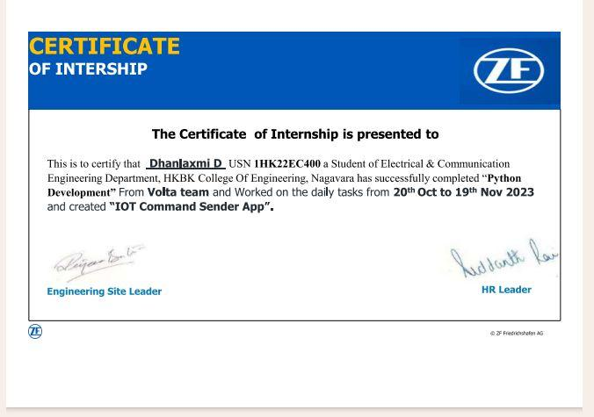

### Python development and backend development

**DEPARTMENT OF ELECTRONICS AND COMMUNICATION ENGINEERING HKBK COLLEGE OF ENGINEERING, BANGALORE-560054**



**DECLARATION**

I, **DHANALAXMI D** bearing **1HK22EC400** student of Vl semester, B.E degree in Electronics and Communication Engineering declare that this Intra Institutional Internship Program(Internship-2) titled **“Python development and backend development ”** is original work carried out by me, the undersigned in the college campus at after endorsement and authorization from competent authorities of HKBK College of Engineering, in partial fulfilment of the Belagavi in the 2023 B.E Degree Choice Based Credit System Scheme.

The content in this report is not submitted to any other university partially or wholly for the award of any other degree.

**DHANALAXMI 1HK22EC400** Vl Sem, B.E

Electronics and Communication Engineering

Date: --/--/2023 Place: Bengaluru

# ACKNOWLEDGMENT

The euphoria that accompany the acquisition of vocational skills by professing internship program and compiling, internship report would be complete only by acknowledging the governing bodies and the personnel, who by their supervision steered and crowned out my eﬀort with success.

I would like to express my profound gratitude to our Director, **Mr. Faiz Mohammed** for setting up a vibrate learning atmosphere and quality procedures that fetched the institution NAAC and NBA accreditation and transcend the institution to the forefront of literary renaissance.

I would like to express my genuine thanks to our Head of the Department, **Dr. Latha R** for facilitating the internship program and her support in our academics and co-curricular activities.

I would like to extend my impassioned thanks and admiration to my Internal Guide**, DR. suriandar .j** Asst Professor, Department of Electronics and Communication Engineering for her enduring encouragement, guidance, training and supervision of my internship program.

DHANALAXMI D

**TABLE OF CONTENT**

COLLEGE CERTIFICATE COMPANY CERTIFICATE DECLARATION ACKNOWLEDGEMENT

|  |  |  |
| --- | --- | --- |
| **CHAPTER 1** | **ABOUT THE INSTITUTION** |  |
| 1.1 | HKBK Group of Institution | 9 |
| 1.2 | HKBK College of Engineering Profile | 10 |
| 1.3 | Vision and Mission | 11 |
| 1.4 | Department of the Institution | 12 |
| 1.5 | Affiliation and Certifications | 13 |

|  |  |  |
| --- | --- | --- |
| **CHAPTER 2** | **ABOUT THE DEPARTMENT** |  |
| 2.1 | Department Infrastructure | 15 |
| 2.2 | Vision and Mission | 16 |
| 2.3 | Affiliations-Achievement and Awards |  |
| 2.4 | Internship Activity Department |  |

|  |  |  |
| --- | --- | --- |
| **CHAPTER 3** | **INTERNSHIP TASKS PERFORMED** |  |
| 3.1 | Introduction of Python | 15 |
| 3.2 | Features of Python | 17 |
| 3.3 | Python Compilation | 18 |
| 3.4 | Sprint Plan Meet | 20 |
| 3.5 | Basic Concepts of Python | 21 |
| 3.6 | Task assigned to me | 25 |
| 3.7 | Programming of application | 26 |
| 3.8 | Testing and deployment | 29 |

#### RECOMMENDATIONS/SCOPE FOR IMPROVEMENT CONCLUSION

**REFRENCES**

## CHAPTER-1

### CHAPTER-1 - ABOUT THE INSTITUTION

#### 1.1 HKBK GROUP OF INSTITUTION 1.2

**1.3** Welcome to the institution dedicated to creating tomorrow’s leaders and today’s pioneers. HKBK Group of Institutions has been consistent to maintain excellence in the academic standards since its inception. Our beautiful 17 Acre campus in the heart of Bangalore city inspires students to succeed professionally and personally in a competitive world. Full form of HKBK is "Have Knowledge Be Knowledgeable “Learning is an enjoyable experience here, with experienced faculty, inspiring libraries, large playgrounds and state-of-the-art labs.

#### 1.4

**1.5** We invite you to explore our campus, our teaching process, laboratories and facilities, and simply discover why HKBK stands as the most preferred destination for students who aspire to grow, learn and reach beyond the country.

### HKBK COLLEGE OF ENGINEERING PROFILE

Engineers possess a rare combination – a seamless blend of the practical and the creative. It’s a profession that tackles society’s challenges and make the world a better place to live. If you have a burning desire to know how things work and want to make an impact on the world around you, engineering is your path. HKBK College of Engineering a place where you'll experience world-class engineering facilities in a supportive learning environment.

Engineering is shaping the future all around us. An Engineering degree from HKBK equips you with the analytical, technical and professional skills needed to solve some of the biggest challenges we face in the world today. Our renowned faculties help you to develop some of the key solutions to major global challenges.

### VISION AND MISSION VISION

To empower students through wholesome education and enable the students to develop into highly qualified and trained professionals with ethics and emerge as responsible citizen with broad outlook to build a vibrant nation

#### MISSION

* To achieve academic excellence through in-depth knowledge in science, engineering and technology through dedication to duty, innovation in teaching and faith in human values.
* To enable our students to develop into outstanding professionals with high ethical standards to face the challenges of the 21st century.
* To provide educational opportunities to the deprived and weaker section of the society, to uplift their socio-economic status

#### DEPRTMENTS OF THE INSTITUTION

* COMPUTER SCIENCE AND ENGINEERING
* INFORMATION SCIENCE AND ENGINEERING
* MECHANICAL ENGINEERING
* ELECTRONICS AND COMMUNICATION ENGINEERING
* ARTIFICIAL INTELLIGENCE AND MACHINE LEARNING
  1. **AFFILIATIONS AND CERTIFICATIONS**

AFFILITED TO:

-Visvesvaraya Technological University

-The Government of Karnataka

-Approved by AICTE

-Approved by AIU

AWARDS:

-Ranked as 22nd best Engineering Colleges in India by CSR-GHRDC Engineering Colleges Survey.

-Ranked as #30th Engineering college in India by SiliconIndia.

-Recognized as best Engineering College for Industry Interactions by Higher Education.

-Career 360 has placed HKBK college in the highest Category AAA.

-Ranked as top #7th best Engineering College in Karnataka by SiliconIndia.

-Ranked one of the TOP 10 Engineering Colleges in Bangalore for Placement.

CHAPTER -2

### DEPARTMENT INFRASTRUCTURE

: HKBK has spacious library with an area of 750 sq. m with more than 7400 titles / 44000 volumes / 110 periodicals. HKBK libraries have subscribed to a number of eBook packages, giving us access to hundreds of thousands of books online. All allow reading the eBook through the browser, and many allow downloading for oﬄine reading or transfer to a mobile device or dedicated eBook reader. Every library has got wireless internet access, places to study and facilities to print, copy or scan.

: Boys Hostel Oﬀ-Campus Hostel, Girls Hostel Oﬀ-Campus Hostel Available Facilities:

: Basketball Court Cricket Ground

: Civil Engineering Lab, Chemistry Lab, Computer Lab, Electronics Lab, Language Lab, Mechanical Lab, Physics Lab

: Cafeteria, Gym, Hospital/Medical Facility, Wi-Fi Campus, Auditorium, Research Centerer,Seminar Hall, Smart Classrooms, Fine Art Club.

#### DEPARTMENT VISION AND MISSION

**VISION**

To shape the students as disciplined humane engineers who can build a strong, peaceful and vibrant country and focus on mutual respect, tolerance and professional ethics.

#### MISSION

* To provide the best possible educational experience through excellence in teaching and research activities for todays students and professionals of tomorrow.
* To hone young minds and train them to be conscientious individuals who will serve the society as competent professionals in the field of Electronics and Communication Engineering.

CHAPTER -3

### INTRODUCTION OF PYTHON

Python is a widely used general-purpose, high level programming language. It was created by Guido van Rossum in 1991 and further developed by the Python Software Foundation. It was designed with an emphasis on code readability, and its syntax allows programmers to express their concepts in fewer lines of code. Python is a programming language that lets you work quickly and integrate systems more efficiently.There are two major Python versions: Python 2 and Python 3. Both are quite different.

**What is Python?**

Python is a programming language that is widely used in web applications, software development, data science, and machine learning (ML). Developers use Python because it is efficient and easy to learn and can run on many different platforms. Python software is free to download, integrates well with all types of systems, and increases development speed.

**What are the benefits of Python?**

Benefits of Python include:Developers can easily read and understand a Python program because it has basic, English-like syntax.

Python makes developers more productive because they can write a Python program using fewer lines of code compared to many other languages.

Python has a large standard library that contains reusable codes for almost any task. As a result, developers do not have to write code from scratch.

Developers can easily use Python with other popular programming languages such as Java, C, and C++.

The active Python community includes millions of supportive developers around the globe. If you face an issue, you can get quick support from the community.

Plenty of helpful resources are available on the internet if you want to learn Python. For example, you can easily find videos, tutorials, documentation, and developer guides.

Python is portable across different computer operating systems such as Windows, macOS, Linux, and Unix.

### APPLICATION OF PYTHON

### Web and Internet Development

* Frameworks such as [Django](http://www.djangoproject.com/) and [Pyramid](http://www.pylonsproject.org/).
* Micro-frameworks such as [Flask](http://flask.pocoo.org/) and [Bottle](http://bottlepy.org/).
* Advanced content management systems such as [Plone](http://www.plone.org/) and [django CMS](https://www.django-cms.org/).
* Python's standard library supports many Internet protocols:
* [HTML and XML](http://docs.python.org/library/markup), E-mail processing
* Support for [FTP](http://docs.python.org/library/ftplib.html), [IMAP](http://docs.python.org/2/library/imaplib.html), and other [Internet protocols](http://docs.python.org/library/internet).
* Easy-to-use [socket interf](http://docs.python.org/howto/sockets.html)ace
* [Requests](https://pypi.org/project/requests/), a powerful HTTP client library.
* [Beautiful Soup](http://www.crummy.com/software/BeautifulSoup/), an HTML parser that can handle all sorts of oddball HTML.
* [Feedparser](https://pypi.org/project/feedparser/) for parsing RSS/Atom feeds.
* [Paramiko](https://pypi.org/project/paramiko/), implementing the SSH2 protocol.
* [Twisted Python](http://twistedmatrix.com/), a framework for asynchronous network programming.

###### Scientific and Numeric: Python is widely used in [scientific and numeric](http://wiki.python.org/moin/NumericAndScientific) computing:

* [SciPy](http://scipy.org/) is a collection of packages for mathematics, science, and engineering.
* [Pandas](http://pandas.pydata.org/) is a data analysis and modeling library.
* [IPython](http://ipython.org/) is a powerful interactive shell that features easy editing and recording of a work session, and supports visualizations and parallel computing.
* The [Software Carpentry Course](http://software-carpentry.org/) teaches basic skills for scientific computing, running bootcamps and providing open-access teaching

### FEATURES OF PYTHON

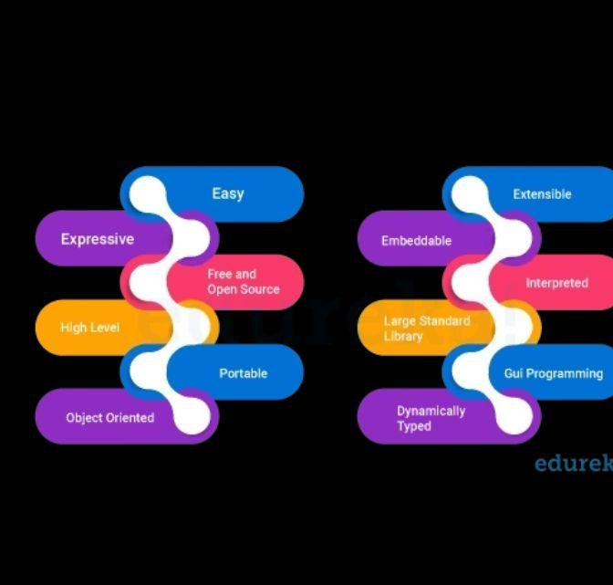

As a programming language, the features of Python brought to the table are many. Some of the most significant features of Python are: **Easy to Code**: Python is a very developer-friendly language which means that anyone and everyone can learn to code it in a couple of hours or days. As compared to other object-oriented programming languages like Java, C, C++, and C#, Python is one of the easiest to learn. **Open Source and Free** :Python is an open-source programming language which means that anyone can create and contribute to its development. Python has an online forum where thousands of coders gather daily to improve this language further. Along with this Python is free to download and use in any operating system, be it Windows, Mac or Linux. **Support for GUI :**GUI or Graphical User Interface is one of the key aspects of any programming language because it has the ability to add flair to code and make the results more visual. Python has support for a wide array of GUIs which can easily be imported to the interpreter, thus making this one of the most favorite languages for developers.

**Object-Oriented Approach :** One of the key aspects of Python is its object-oriented approach. This basically means that Python recognizes the concept of class and object encapsulation thus allowing programs to be efficient in the long run. **High-Level Language :** Python has been designed to be a high-level programming language, which means that when you code in Python you don’t need to be aware of the coding structure, architecture as well as memory management. **Integrated by Nature :** Python is an integrated language by nature. This means that the python interpreter executes codes one line at a time. Unlike other object-oriented programming languages, we don’t need to compile Python code thus making the debugging process much easier and efficient. Another advantage of this is, that upon execution the Python code is immediately converted into an intermediate form also known as byte-code which makes it easier to execute and also saves runtime in the long run. **Highly Portable :** Suppose you are running Python on Windows and you need to shift the same to either a Mac or a Linux system, then you can easily achieve the same in Python without having to worry about changing the code. This is not possible in other programming languages, thus making Python

* 1. PYTHON COMPILATION

### Compilation Process in Python

## Understanding Python Compilation

During the compilation process, the Python interpreter analyzes the code, checks for syntax errors, and generates an optimized representation of the code known as bytecode. Bytecode is a low-level representation of the code that is specific to the Python virtual machine (PVM). The PVM then executes the bytecode to perform the desired operations.

.

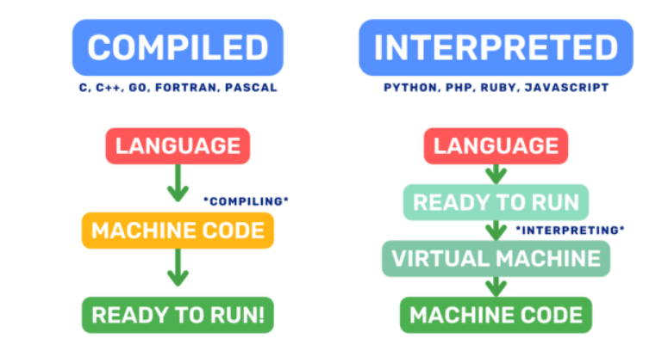

### Differences between interpreted and compiled languages

Python is often referred to as an interpreted language because the Python interpreter executes the code line by line, interpreting and executing each statement as it encounters them. This interpretive nature of Python offers advantages like easy prototyping, dynamic typing, and runtime flexibility. However, it also introduces some performance overhead.

In contrast, compiled languages, such as C++ or Java, go through a separate compilation step before execution. The source code is compiled into machine code specific to the target platform, resulting in faster execution. The compiled program can be directly executed by the computer without the need for an interpreter.

### Advantages of compiling Python code

Improved Performance

Early Error Detection

Code Protection

Integration with Other Languages

### SPRINT PLAN MEET

• **Introduction and Objectives**

* Welcome everyone and provide an overview of the meeting's purpose.
* Outline the goals and objectives of the upcoming sprint.

• **Review of Previous Sprint**

* Discuss the outcomes of the previous sprint.
* Review any unfinished tasks or issues that need to be carried over.

• **Product Backlog Review**

* Review the product backlog items that are prioritized and ready for sprint planning.
* Discuss any changes in priorities or new backlog items.

• **Team Capacity and Velocity**

* Review the team's capacity for the upcoming sprint (based on availability, skills, etc.).
* Discuss the team's velocity and past sprint performance metrics if applicable.

• **Selection of Sprint Goal**

* Define a clear sprint goal that aligns with the overall project objectives.
* Ensure that the sprint goal is specific, achievable, and measurable.

• **Task Breakdown and Estimation**

* Break down the selected backlog items into specific tasks.
* Assign tasks to team members based on their skills and expertise.
* Estimate the effort (story points, hours, etc.) required for each task.

• **Definition of Done**

* Review and confirm the Definition of Done (DoD) for the sprint.
* Ensure everyone understands the criteria that must be met for each task to be considered complete.

• **Dependencies and Risks**

* Identify any dependencies between tasks or with external factors.
* Discuss potential risks that could impact the sprint's success.
* Develop mitigation plans for high-priority risks.

• **Sprint Timeline and Schedule**

* Define the sprint duration (e.g., 1-4 weeks) and specific start/end dates.
* Confirm any planned milestones, checkpoints, or meetings within the sprint.

• **Tools and Communication**

* Confirm the tools and systems (e.g., JIRA, Trello) to be used for task tracking and communication.
* Clarify how progress will be communicated (daily stand-ups, status reports, etc.).

### BASIC CONCEPTS OF PYTHON

### 1. Variables and Data Types

Python uses dynamic typing, which means you don't need to declare variables explicitly. Here are examples of basic data types:

# Integer

age = 25

# Float

height = 1.75

# String

name = "Alice"

# Boolean

is_student = True

### 2. Lists

Lists are ordered collections of items. They can contain elements of different types and are mutable (can be changed).

# List of integers

numbers = [1, 2, 3, 4, 5]

# List of strings

fruits = ["apple", "banana", "cherry"]

# Mixed list

mixed_list = [10, "hello", True]

### 3. Control Flow Statements

#### If-Else Statements

x = 10

if x > 0:

print("Positive number")

elif x < 0:

print("Negative number")

else:

print("Zero")

##### **For Loop**

# Iterating over a list

fruits = ["apple", "banana", "cherry"]

for fruit in fruits:

print(fruit)

**While Loop**

# Looping until a condition is met

count = 0

while count < 5:

print(count)

count += 1

### 4. Functions

Functions in Python are defined using the def keyword. They can take parameters and return values.

# Function to calculate the square of a number

def square(x):

return x * x

# Using the function

result = square(5)

print("Square of 5 is:", result)

### 5. Dictionaries

Dictionaries are unordered collections of key-value pairs.

# Creating a dictionary

person = {

"name": "Alice",

"age": 30,

"city": "New York"

}

# Accessing values using keys

print("Name:", person["name"])

print("Age:", person["age"])

### 6. Classes and Objects

Python supports object-oriented programming. Here's a simple example of defining a class and creating objects:

# Class definition

class Car:

def __init__(self, make, model):

self.make = make

self.model = model

def display_info(self):

print(f"Car: {self.make} {self.model}")

# Creating objects (instances) of the class Car

car1 = Car("Toyota", "Camry")

car2 = Car("Honda", "Accord")

# Accessing object attributes and methods

car1.display_info()

car2.display_info()

### Example Program: Calculating Factorial

Here's a complete example that calculates the factorial of a number using recursion:

def factorial(n):

if n == 0:

return 1

else:

return n * factorial(n - 1)

# Example usage

number = 5

fact = factorial(number)

print(f"Factorial of {number} is:", fact)

### Explanation:

* **Variables and Data Types**: Shows how to declare variables and different data types (integer, float, string, boolean).
* **Lists**: Examples of creating lists and accessing list elements.
* **Control Flow Statements**: Includes if-else statements and loops (for and while).
* **Functions**: Defines a function to calculate the square of a number and demonstrates its usage.
* **Dictionaries**: Shows how to create dictionaries and access values using keys.
* **Classes and Objects**: Defines a Car class with attributes and a method, and creates instances of the class.
* **Example Program**: Demonstrates a factorial calculation function using recursion.

### TASK ASSIGNED TO ME

**Pc App for sending command to Device**

**This App will be useful when we want to send the commands to device remotely.**

**Steps to followed**

* IMEI has to be entered
* Command has to be entered
* The Command will be sent to device remotely by this app.

**Security is also taken care for this which has key and Aws certificates to send the commands.**

**UI View:-**

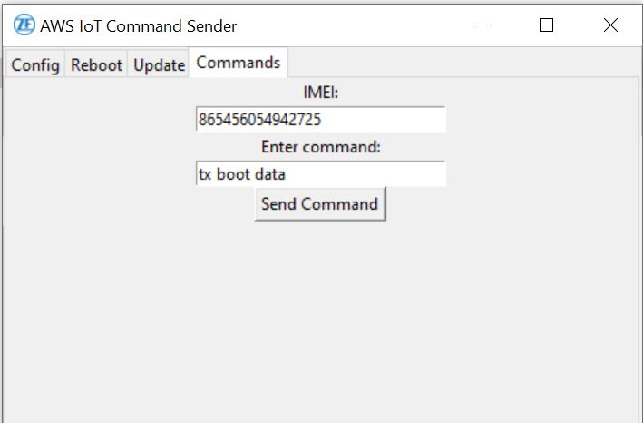

### PROGRAMMING OF APPLICATION

The Version has to specify for the development of any application or program so it is necessary to maintain the new features to added with incremental version and bug fixes, etc..

The Packages and Modules list are as below to be used to achieve the goal are

AWSIoTMQTTClient // for the device IOT aonnectiivity

from PIL import Image, ImageTk // for handling the Image

from tkinter import ttk // to create the Window of UI in table view or required titles

**############################################################################**

#ver 240417.1.1.0

from AWSIoTPythonSDK.MQTTLib import AWSIoTMQTTClient

from tkinter import *

from PIL import Image, ImageTk

import tkinter as tk

from tkinter import ttk

# Replace these values with your specific configurations

ca_file = 'AmazonRootCA1.pem'

cert_file = 'f3d819d7d3a363726369988a46e20d08f184b60a6b7f5cb7419aa6842ae598b7-certificate.pem.crt'

key_file = 'f3d819d7d3a363726369988a46e20d08f184b60a6b7f5cb7419aa6842ae598b7-private.pem.key'

mqtt_host = 'a9tto1qihmqxh-ats.iot.eu-west-1.amazonaws.com'

# Initialize MQTT client

mqtt_client = AWSIoTMQTTClient("MyClientID")

mqtt_client.configureEndpoint(mqtt_host,8883)

mqtt_client.configureCredentials(ca_file, key_file, cert_file)

# Connect to AWS IoT

mqtt_client.connect()

#To get the commad from the user to send the data to aws server subcribered to mentioned topic

def send_command():

command = command_entry.get() # Get command from entry field

imei = imei_entry.get()

mqtt_topic=f"incoming/$/$/{imei}/$/$"

payload = command

print("imei is:", imei)

print("command entered is:",command)

mqtt_client.publish(mqtt_topic, payload, 1)

# Create the Tkinter window

root = tk.Tk()

root.title("AWS IoT Command Sender")

# Open and resize the image

image = Image.open("ZF_logo.png")

image = image.resize((16, 16)) # Resize the image to fit as an icon

# Convert the image for Tkinter

tk_image = ImageTk.PhotoImage(image)

# Set the image as the window icon

root.iconphoto(True, tk_image)

notebook = ttk.Notebook(root)

notebook.pack(fill='both', expand=True)

# Tool tab (similar structure as Config)

tool_tab = Frame(notebook)

notebook.add(tool_tab, text='Config')

# Tool tab (similar structure as Reboot)

tool_tab = Frame(notebook)

notebook.add(tool_tab, text='Reboot')

# Tool tab (similar structure as Update)

tool_tab = Frame(notebook)

notebook.add(tool_tab, text='Update')

# Command tab

command_tab = Frame(notebook)

notebook.add(command_tab, text='Commands')

# UI Tab with 30mm width of entry box of the IMEI

command_label = Label(command_tab, text="IMEI:")

imei_entry = Entry(command_tab)

command_label.pack()

imei_entry = Entry(command_tab, width=30)

imei_entry.pack()

# UI Tab with 30mm width of entry box of the Command

command_label = Label(command_tab, text="Enter command:")

command_entry = Entry(command_tab)

command_label.pack()

command_entry = Entry(command_tab, width=30)

command_entry.pack()

# UI Button which will send the entry.

send_button = Button(command_tab, text="Send Command", command=send_command)

send_button.pack()

#To run in a loop

root.mainloop()

**The Subcribed Topic from the device End:-**

awsmqtt_subcribed(const sysData &sys){

  char buffer[SIZE_100];

  char data[SIZE_2040];

  snprintf(data, sizeof(data), "mosquitto_sub --cafile  /userdata/apps/Electrace/%s --cert /userdata/apps/Electrace/%s --key /userdata/apps/Electrace/%s -h a9tto1qihmqxh-ats.iot.eu-west-1.amazonaws.com -t incoming/$/$/%s/$/$" ,sys.awsRootCA,sys.awsCert,sys.awsKey,sys.productImei);

  while(true){

     FILE *pipe_fp = NULL;

    // Open mosquitto_sub command as a pipe

    pipe_fp = popen(data, "r");

    if (pipe_fp == NULL) {

        perror("popen");

    }

    // Read messages from the pipe and print them

    while (pipe_fp != NULL && fgets(buffer, sizeof(buffer), pipe_fp) != NULL) {

        printf("Received message: %s", buffer); // Print or process the message as required

        system(buffer);

    }

    // Close the pipe

    if (pipe_fp != NULL)

    pclose(pipe_fp);

}

}

* 1. **Testing and deployment**

The certificate and Topics should be in device end must be placed and then take the IMEI number,

The Device must be SUBCRIBE to given topic then only it will receive the Data sent From the App.

**Trail 1**

**INPUT from the APP:-**

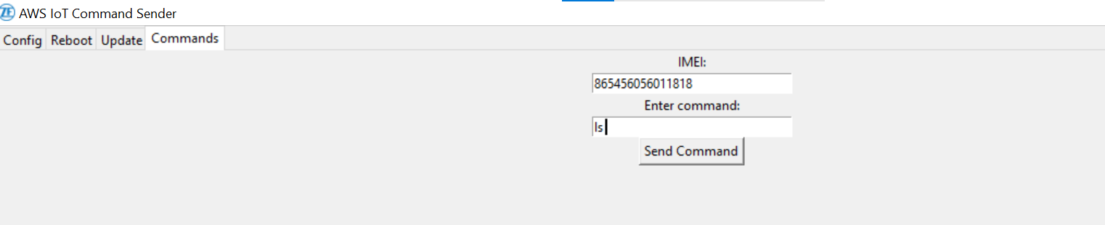

**OUTPUT IN THE DEVICE END:-**

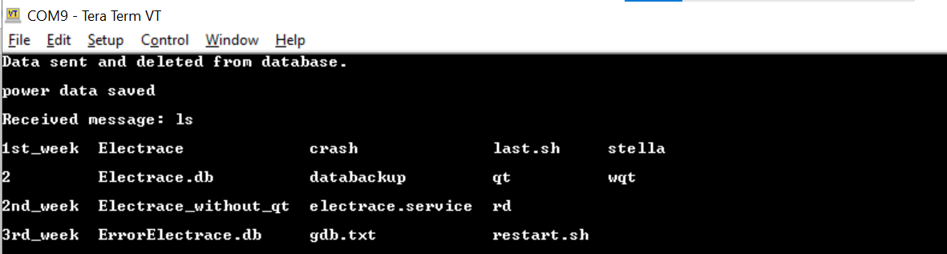

**Trail 2**

**INPUT:-**

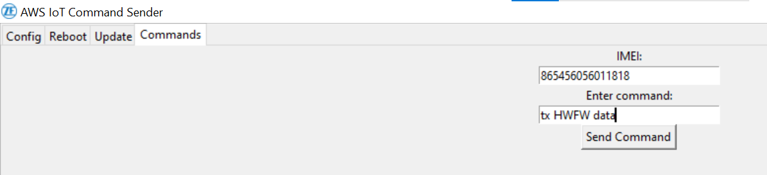

**OUTPUT:-**

